MUSEUM OF THE FORGOTTEN WARRIORS
NEWSLETTER # 18 August 2019
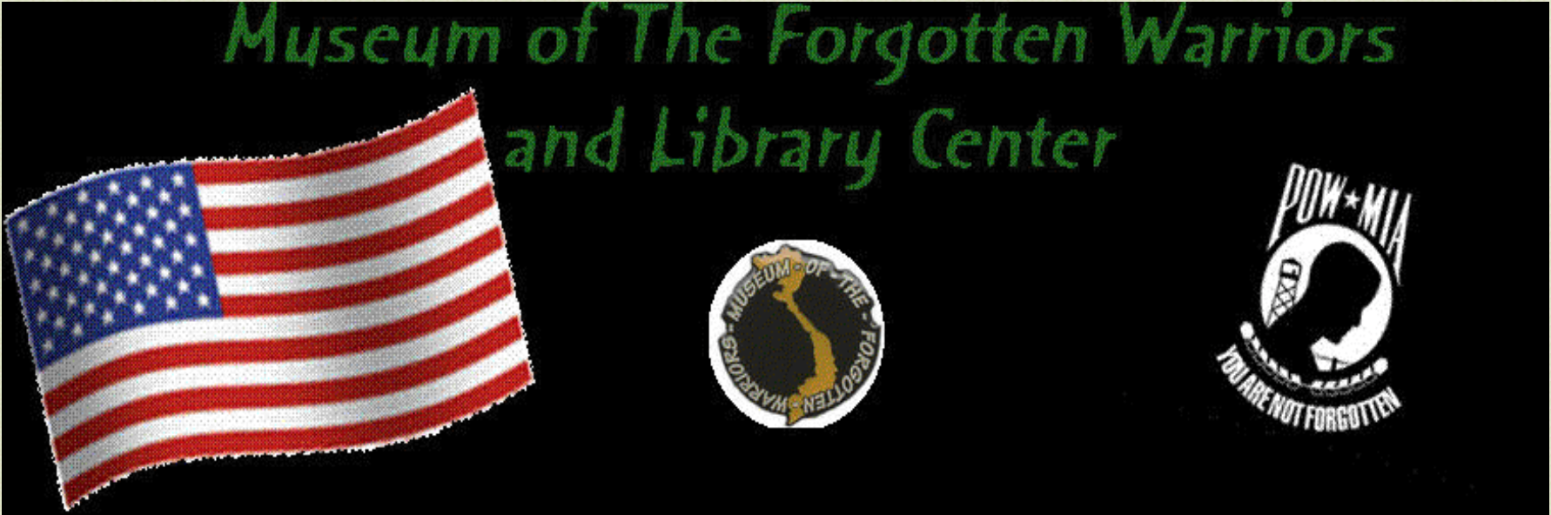

Hello, everyone,

August and summer are drawing to a close. Sunday, I expect to be awakened by gunshots . . . dove season. That is how I know it’s fall!

August had some hot days but we had a regular flow of visitors at the museum. A group of seniors from Roseville and forty marine recruits and their recruiters were among those who visited.

The Yuba/Sutter Stand Down took place on August 21 through August 23. The museum was well represented.

We are participating in the traveling Vietnam Wall being displayed at Yuba College. Opening ceremonies are Friday, September 13. Please come out and see the wall and the museum items on display. Bring your kids and grandkids and teach them.

We had a visit from Mr. Mark Olsen. The patio is dedicated to his Dad, Lee Olsen. I was so happy for Mark to see the patio completed.

We continue to receive donations and find places for them.

Come and hang out with us every Saturday. We always have good food and a good time.

For Dann

Roberta

