MUSEUM OF THE FORGOTTEN WARRIORS
NEWSLETTER #6 August 2018
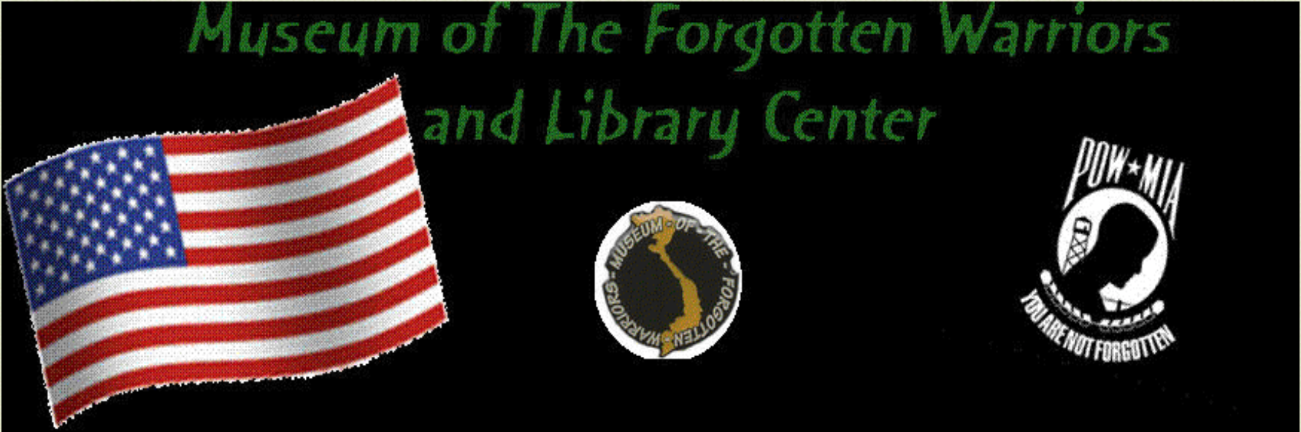

Dear Volunteers,

August is almost past! Cooler weather is awesome. Thank you MOTFW volunteers for your help this month. It has been another busy one. Bill, Jack, Don, Tony, Ray, Larry, Richard, Austin, and Ceder all put in some hours. I appreciate your dedication to the museum and your help to me!

Thank you to the Yuba/Sutter Stand Down for recognizing me and dedicating the Stand Down to Dann. Very touching and appreciated!

Yesterday, about fifty young Marine recruits along with their sergeant recruiters toured the museum and had a BBQ. So nice to pass on your history to young people. One young man commented he had never met a Vietnam veteran. That got some chuckles!

The patio is basically finished. Everyone can check it out at the annual Christmas party. More to come on that later.

The NRG will be working on the SR-71 start cart and other vehicles during the next month, and there are rumors of an aircraft engine with blades that may find a home at the museum. . .

We even had the Sheriff’s Office use the back parking lot for training. There was lots of noise that day.

Don will give a tour to a visitor from Australia on Monday.

Folks continue to bring us their memories to hold and share. All stories need to be preserved and are equally important to me as they were to Dann.
I met Colonel Larry Broadwell, Commander, 9th Reconnaissance Wing, Beale AFB, at the Stand Down and invited him to visit the museum. I believe he will do so soon.

For Dann,

Roberta

