MUSEUM OF THE FORGOTTEN WARRIORS (rev 6/19)

This is a list of displays with interesting personal stories.

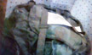
A-3, DV-30: A US Army issue Alice backpack with metal frame was listed as captured from the VC/NVA on war trophy registration paperwork. This “slight of hand” was the only way Ron Hill could bring home a US Army issued item. Ron served at Xuan Loc, Vietnam, with the 199th Light Infantry Brigade military police working on the V-100 vehicles. He was a Canadian citizen living in the US and was drafted to go to Vietnam. When he got home, he applied to become a member of the VFW and the American Legion and was told he was ineligible because he was not a US citizen, even though he spent a year in Vietnam fighting with the US Army. He became a US citizen later and the VFW and American Legion asked him to join. He said no and told the organizations to stick it!

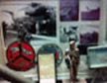
A-4, DV-275: In the upper left corner of this display is an 8 x 10 black and white photo of marine helicopter on an aircraft carrier unloading people evacuated from the Saigon embassy. Marine Corps Sergeant Skip Perry was a crew chief on one of these evacuation helicopters that evacuated the Saigon and the Phnom Penh embassies during Operation Frequent Wind during the fall of Saigon in April 1975. The helicopters flew back and forth from the USS Hancock, CV-19 and other aircraft carriers. The evacuees were then taken to the Philippines.

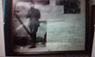
A-4, DV-2241: A signed photo and personalized letter sent to Dann Spear by Martha “Maggie” Rae, a comic actress during the 1940s and 1950s. She was a colonel in the US Army Nurse Corps Reserve. She spent a total of 25 months in Vietnam over several years entertaining and lending a helping hand with the wounded. She canceled a show at a base in the Mekong Delta in October 1966 to tend soldiers wounded in a Viet Cong attack. In recognition of her extraordinary efforts, President Lyndon Johnson awarded her a green beret and the honorary rank of lieutenant colonel in the Special Forces. She is the only woman to be buried in the Special Forces cemetery at Ft. Bragg, California.

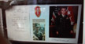
A-5, DV-56: A 1986 handwritten letter to Dann Spear from General Westmoreland congratulating Dann for his creation of the museum. It was signed on his personal letterhead stationary. He enclosed a color military assistance command, Vietnam (MACV) patch he wore and a signed 8 x 10 color photo of himself.

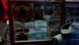
A-6, DV-15: In this display is a Tonkin Gulf Yacht Club patch issue to Roy Hicks. Roy served in the Navy in Vietnam and joined the California National Guard when he got out. He was directed to return to active duty during Iraqi Freedom. He was 62 years old and had just one year left to retirement. He said the heat nearly killed him.

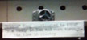
A-6, DV-22: A silver peace ring. It was given to Tony Newman when he arrived in Vietnam as the new guy at the 90th Replacement Battalion. A guy leaving to go home threw it to Tony and said it had brought him good luck. Tony wore it. While serving on a Sheridan tank, he go orders to go to sniper school and left. A while later, the tank was destroyed by enemy fire. Tony was convinced the ring saved his life. If he had not received orders for sniper school, he would have died.

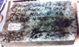
A-7, DIF-97: A piece of marble flooring removed from one of Saddam Husain’s palaces. It was signed with the story and brought home by Ken Voss. Ken was a civilian contractor working in Iraq during Operation Iraqi Freedom.

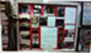
B-11, DV-326: Several photos and orders of Carl Westenberg. Carl served with the Special Forces as an Army Green Beret in Task Force 1 Advisory Element in Vietnam. He was shot down in 1972 and became a paraplegic. Carl returned home in a wheelchair and was spit on at the San Francisco Airport by war protesters.

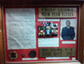
B-11, DV-260, 261: Eric “Doc” Luoma experienced a long and highly decorated career in the US Navy that included atomic testing at Bikini Atoll, and UDT training. He later became a SEAL and served in Vietnam. He had a sense of humor. He placed a V for valor on his Silver Star ribbon, an unnecessary and incorrect placement, searching for imposters. If anyone mentioned that he too had a V for valor on his Silver Star, Eric knew he was an imposter.

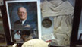
B-14, DWII-208: In this display is a 8 x 10 color photo of Chief Master Sergeant Robert Brown, US Air Force, and a small photo of Robert signing his canteen that he carried on the Bataan Death March. Robert was just 17 years of age when the Japanese overran the Philippine Islands in 1942. He survived the march and was sent to a POW camp in Mukden, China. When he arrived, he weighed just eighty pounds. While a prisoner, he learned to speak Japanese and was able to help other POWs who were ill and wounded by serving as an interpreter. For this service, he received two written commendations from the Japanese camp commander. He and approximately 1,300 other prisoners were liberated on August 16, 1945. After returning home to Marysville, California, Bob continued to serve in the Air Force and retired on October 6, 1969 as a chief master sergeant.
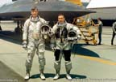
B-14, DV-300. Tony Bevacqua is a local Air Force legend. He retired as a lieutenant colonel and is one of only twelve to have piloted both the SR-71 and the U-2 spy planes.
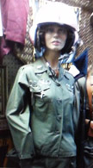
B-14, DV-2359, 2361: Sandy Peterson was a nurse at Quang Tri. Her best friend, CWO2 Robert Oren Hill, a helicopter pilot, taught her to fly the Bell UH-1H Iroquois, known as a Huey, although this was against regulations. Sandy’s call sign was DMZ Angel. Bob was a Dustoff helicopter pilot. Dustoff in Vietnam was a crew of four dedicated men that flew unarmed helicopters to the front line and beyond to rescue wounded soldiers. Hill was searching for a lost Dustoff helicopter and was last heard from at approximately 2245 on September 27, 1970. The helicopter was found the next morning. It had apparently crashed and all on board were killed.

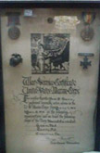
B-15, DWII-190: A large WWI War Service certificate, United States Marine Corps awarded to Arthur Davis, the father of Edie (Davis) Galbraith. Arthur is the grandfather of Col. Nicoll Galbraith Jr. who financed the construction the large building. Arthur served on the island of Guam with a Marine Corps detachment. His unit had the distinction of firing the first American shots in WWI against the Germans. They discovered SMS Cormoran II, (the renamed German-captured Russian SS Ryazan) tied up at the dock in Apra Harbor. They proceeded to capture the vessel. This action occurred just two hours after the US had declared war on Germany
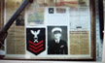
C-20, DWII-138: Chief petty officer gunners mate Frank Carson was stationed aboard the USS Oklahoma BB-37 in Pearl Harbor on December 7, 1941. The Oklahoma was capsized, killing many sailors. Frank was blown off the fantail and survived to fight throughout the Pacific during the war. After the war, Frank found employment as a Tennessee state game warden. He did not talk about his war experience until Dann Spear asked questions about the display.

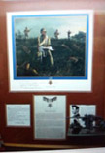
C-20, DWII-168: A large print signed to Dann Spear of Sergeant Mitchell Paige’s October 1942 action against the Japanese on Guadalcanal and a copy of his Medal of Honor citation. Marine platoon Sergeant Mitchell Paige and his platoon repelled repeated enemy charges in fierce hand-to-hand combat on Guadalcanal protecting Henderson airfield. When all of his men were either dead or wounded, he ran back and forth between machine guns firing them to let the Japanese think there were a lot of marines. Two rifle companies were stalled behind him waiting to move forward. Sergeant Paige yelled to the riflemen to fix bayonets, he was going over the hill. He strapped two belts of ammo over his shoulders, unclamped one of the red-hot 30 cal. machine guns from its footing, and charge directly into the Japanese line destroying the last of the resistance. He was awarded the Congressional Medal of Honor on May 21, 1943. Thirty-three marines fought 2,500 Japanese. Sergeant Paige was unable to talk about this battle for fifteen years.

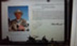
C-20, DWII-278 and 279: A large frame signed to Dann Spear with a photo of Master Sergeant Richard K. Sorenson, retired, wearing his Congressional Medal of Honor and a copy of the citation. Marine private Sorenson was awarded the medal for conspicuous gallantry and intrepidity while serving with an assault battalion attached to the Fourth Marine Division during the battle of Namur Island, Kwajalein Atoll, Marshall Islands on February 1-2, 1944. He and five other Marines occupied a shell hole into which a Japanese grenade was thrown. Sorenson hurled himself on the grenade, taking the full impact of the explosion. He was seriously wounded but survived. His comrades were saved. He recovered from his wounds and was discharged as a sergeant in 1946. He enlisted in the Marine Corps Reserve a year later and was recalled to active duty in the regular Marine Corps in 1950. He rose to the rank of master sergeant and received a temporary rank of first lieutenant before retiring at which time was returned to his permanent rank of master sergeant.

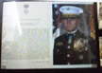
C-26, DV-763: Formal portrait of Major General James Livingston with his Congressional Medal of Honor certificate. James was a marine captain and commanding officer of Company E when on May 2, 1968 the company launched an assault on the heavily fortified village of Dai Do, Vietnam. The enemy had surrounded a marine company the previous evening. James led his men across 500 meters of open rice paddy under intense fire. He was wounded twice, refused medical treatment, and continued to lead his men in the destruction of over 100 supporting bunkers, driving the enemy from their positions and relieving the pressure on the stranded marine company. He joined his company with the stranded company, continued to fight, was wounded a third time, and now was unable to walk. He continued to direct and supervise until his men were safe. He then allowed himself to be evacuated.

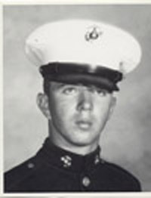
C-27, DV-1016: Large framed photograph of Roy M. Wheat. Roy was a lance corporal assigned as a rifleman with Company K, 3rd Battalion, 7th Marines, 1st marine Division in Vietnam. On August 11, 1967, he and two other marines were assigned to provide security for a Navy construction battalion crane and crew. Roy stepped on a well-concealed bounding mine. Hearing the distinctive hiss of the mine’s fuse, he shouted a warning to the other two and then threw himself on the bomb. He was killed but saved the lives of his close friend Vern Sorensen and the other marine. Roy was awarded the Congressional Medal of Honor. Roy’s mother asked that Vern escort his body home. Vern is a member of the museum board of directors and is quick to tell all that Roy saved his life.

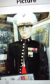
C-28, DKW-267: The uniform of G. B. Tucker. He was an enlisted China Marine of the 4th Marine Regiment during the Korean War. He survived the bitterly cold and windy Battle of Chosin Reservoir. This battle is considered the most momentous and most brutal battle in American history and the most renowned battle in Marine Corps history. He was promoted to 2nd Lt. after his Korean service and then did two tours in Vietnam.

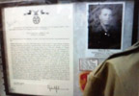
C-33, DV-816: Drew Dix was a Ssgt during the TET offensive and was in the Chau Doc Province of Vietnam. He was a Special Forces advisor with a handful of Vietnam soldiers. The Viet Cong had taken over the city of Chau Phu resulting in a breakdown of the defenses of the city. Dix spent the next 56 hours slowly gaining a foothold in the city. Each time he and his men were successful, more Vietnamese soldiers joined them. They were successful in killing more that 200 Viet Cong and capturing an important Viet Cong leader. They successfully retook the city, a rare positive note in the TET offensive. For this service, he was awarded the Congressional Medal of Honor. He was the first enlisted Special Forces soldier in the Vietnam War to receive this award. Dix remained in the Army, became an officer and retired as a Major.

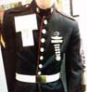
C-35, DWII-13: Corporal Don Lehman served as a marine during WWII and earned two battle stars and his jump wings. He was from Yuba City. He got out of the Marine Corps as a corporal, received a commission from ROTC at UC Davis and retired as a BGEN

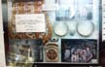
C-35, DAF-6: Corporal E. Thompson served with the A Combat infantry unit in Afghanistan. She was awarded he combat medic’s badge and is jump qualified with the 82nd Airborne.

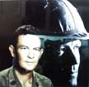
C-36, DKW-112: First Sgt. Shirl Todd was from Colusa. He was a part of the 1st Marine Division and the Battle at Chosin Reservoir and survived. This battle was one of the most celebrated in Marine Corps annals and very decisive in the Korean War.

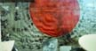
C-39, DWII No #: This Japanese flag was captured during the Battle of Attu. Attu and Kiska were islands off the coast of Alaska that the Japanese had taken unopposed in June 1942. The battle occurred during the last part of May 1943. It was a two- week battle that ended when most of the Japanese defenders were killed in brutal hand-to-hand combat. The flag was donated by Maury Powell

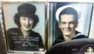
C-40, DWII-1159, 1160: Frank and Mary Sorja were married and served in WWII. Frank was a chief petty office in the Navy and Mary was a Marine. They served in separate places during the war.

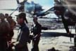
C-40, DWII-No #: Paul Tibbets was the pilot of the Enola Gay and Theodore “Dutch” Van Kirk was the navigator. The Enola Gay was named after Paul’s mother, Enola Gay Tibbets. Dutch Van Kirk visited the museum and had his photo taken with Dann.

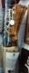
C-40, DWII-866: David Williams, a WWII veteran, arrived at the museum one day with this artificial leg. He had kept it since the war and just wanted to get rid of it. The leg has quite a history. Italy 1945. Two weeks before the end of WWII, David Williams was caring for a wounded soldier on the battlefield. Snipers opened fire forcing medic Williams into a foxhole that the enemy had booby-trapped with explosives. The explosion caused injury that led to the amputation of his left foot and ankle. Upon returning to the States, a second surgery was required at Bushnell General Hospital, Brigham City, Utah, that removed his leg four inches below the knee. The healing process took more than two years and several hospitalization

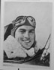
D-50, DWII-1765-1775. Second Lt. Everett Luther Harris piloting his P-38 Lightening had engine trouble over Italy on his very first mission on November 18, 1944. He was a part of the 14th Weather Reconnaissance Squadron conducting unarmed photographic reconnaissance. Harris parachuted out of his aircraft but did not survive. A farmer gathered the pilot’s personal effects and buried the body. He stored the effects in a box in his basement. The farmer passed away in 2012 and his son found that box. The son contacted someone in Italy who contacted someone in Kentucky who worked on returning such personal effects to the next of kin. It was discovered that Harris had attended Yuba City High School and Yuba College and that he had a brother still living in Yuba City. Arrangements were made to send the belongings to Harris’s brother. Harris’s brother attempted to give the belongings to Beale Air Force Base but Beale authorities said they would have to be sent the National Museum of the USAF at Wright-Patterson Air Force Base outside of Dayton, Ohio. The brother was aware of the Museum of the Forgotten Warriors and called museum board member Don Schrader and asked him if the museum wanted the stuff. Don said yes and this display was created in November 2016. Harris’s wife was alive at the time and living in Paradise. One of the twists to this story is that his wife was during the war building the P-38, the same aircraft Harris was flying. She tried to get him to promise he would never fly a P-38.

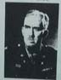
D-59, DWII: Colonel Nicoll Galbraith was General Jonathan Wainwright’s (commander of US forces in the Philippines) G-4 logistics staff officer. Colonel Galbraith, his wife, and three children were stationed in the Philippines when the islands fell to the Japanese in May 1942. The family was evacuated. Galbraith remained behind and was with General Wainwright at the surrender of Corregidor. He then was ordered north to effect the surrender of “guerilla” forces. He spent three and one-half years as a Japanese prisoner at Camp Hoten in Manchuria with 1,400 other American POWS. The camp was liberated in August 1945. For his service, he was awarded the Distinguished Service Medal, the Silver Star with Oak Leaf Cluster, the Legion of Merit, the Bronze Star with “V”, and the Purple Heart with Oak Leaf Cluster.

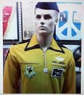
D-62, DV-1011: Mustard colored unofficial uniform worn by pilots at parties at the officer’s club as a joke after missions in Vietnam to allow the wearing of unofficial patches and ribbons. The uniforms were created by a Vietnamese tailor, using the ugliest polyester fabric possible.

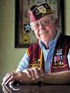
D-66, Local WWII legend. Ollie B. (Obie) Wickersham was a part of the 82nd Airborne Division as the Allies stormed the beach at Anzio. He parachuted into Holland during Operation Market Garden and fought in the Battle of the Bulge. He returned home a highly decorated paratrooper. Five years later, he was called up again to serve in the Korean War as a platoon sergeant. He was captured and forced to join other prisoners in a 500-mile death march through the mountains into North Korea. He spent 28 months enduring brutality, dysentery, and malnutrition. Of the 500 men, 200 survived. When he was rescued, he weighed just 90 pounds. He lives locally.

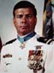
D-69, Vietnam. SEAL Michael Thornton was awarded the Congressional Medal of Honor as a Navy petty officer serving as Assistant US Navy Advisor. He was with a SEAL lieutenant serving as Senior Advisor and a 3-man Vietnamese Navy SEAL patrol on an intelligence gathering and prisoner capture operation against an enemy-occupied naval river base. They came under heavy fire, managed to kill or hold off thirty to forty enemy. During the battle, the lieutenant was seriously wounded and left for dead by the Vietnamese SEALs. Thornton went back to check and found the lieutenant alive. He carried the lieutenant toward the beach while holding off the enemy. He supported the lieutenant and a wounded Vietnamese for hours in the sea until a naval vessel saw them and rescued them. All five of them survived. Later, the lieutenant was awarded the Congressional Medal of Honor for a previous action. It was one of those very rare situations in which a CMH SEAL saved the life of another CMH SEAL.

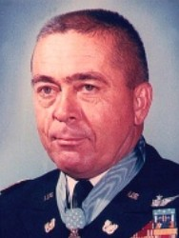
D-78, Vietnam: Michael Novosel piloted B-29s in World War II and was one who flew over the surrender ceremonies in Tokyo. He resigned his Air Force Reserve commission when he was refused duty in Vietnam. He joined the Army as a Warrant Officer. He and his son were the only father/son medical evacuation pilots in Vietnam, together evacuating more than 8,000 wounded and over a span of a few weeks, rescued each other after their helicopters went down. These pilots were called DUSTOFF and operated with no armament or protective cover. When Novosel retired in 1985, he was the last World War II pilot still on active duty. Novosel was awarded the Congressional Medal of Honor for a particularly difficult rescue of twenty-nine soldiers requiring fifteen separate extractions.

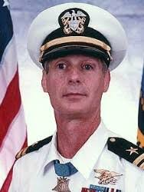
D-79, Vietnam, SEAL Thomas Norris was awarded the Congressional Medal of Honor as a Navy lieutenant for completing an unprecedented ground rescue of two downed pilots deep within heavily controlled enemy territory in Quang Tri Province. On April 10, he led a 5-man patrol through 2,000 meters of enemy territory, found the first pilot, rescued him, and returned him to the forward operating base. He then led a 3-man patrol in two unsuccessful rescue attempts for the second pilot. On April 12, the second pilot was located. Dressed in fishermen disguises and using a sampan, Norris and Petty Officer 3rd Class Nguyen Van Keit traveled throughout the night and, after experiencing serious machine gun fire, managed to recover the second pilot. Petty officer Van Kiet was awarded the Navy Cross.

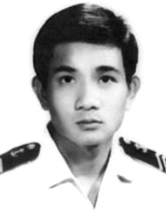
D-79, Vietnam, Nguyen Van Kiet was a member of the Navy of the Republic of Vietnam. On April 13, he volunteered to accompany US SEAL Advisor Thomas Norris in an extremely hazardous attempt to reach the second of two downed pilots who was physically unable to move toward friendly positions. Using a sampan and dressed as fishermen, the two traveled throughout the night deep in enemy territory and were successful in rescuing the pilot. Petty Officer Van Kiet was one of two Vietnamese awarded the Navy Cross during the Vietnam War. The Navy Cross is the highest award that can be presented to members of foreign military units operating with American Forces.

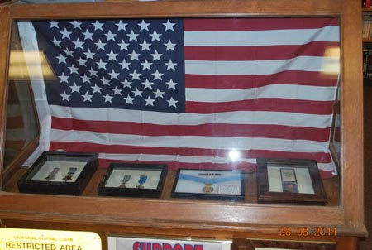
E-83, Congressional Medal of Honor Display. Navy Medal of Honor 1913-1917; Navy Medal of Honor 1917-1942; Air Force Medal of Honor 1960-Present; Army Medal of Honor 1862-1896

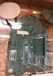
E-84 DWII, Adolph Hitler’s green military jacket with white and green hats. These items were brought home from Germany by a friend of Colonel Nicoll Galbraith at the end of World War II. They were given to Colonel Galbraith who gave them to his son Colonel Nicoll Galbraith Jr who kept them for a number of years and then donated them to the museum. Although there is no official chain of custody, and the display is labeled a copy, it is certain these items belonged to Adolph Hitler.

