MUSEUM OF THE FORGOTTEN WARRIORS
NEWSLETTER # 13 MARCH 2019
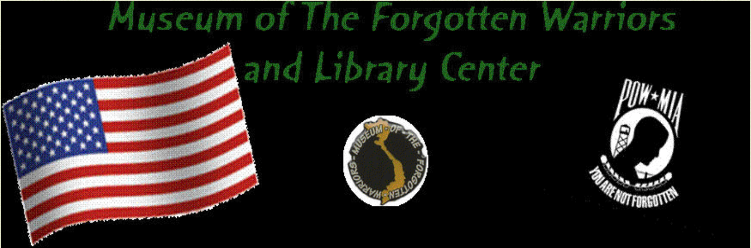

Dear Volunteers,

Roberta is out of town for a couple of weeks, so Bill was asked to write the March newsletter.

Bert Johnson continues to work hard on the second helicopter blade. He is nearly finished painting Vietnam War scenes. When it is completed, it will be hung on the wall in the picnic area. Jack is in charge of the hanging.

Two Civil War rifles have been promised to the museum. Arrival date is not certain.

The museum board of directors met Saturday, March 9, at 0900. Roberta reviewed the activities of the museum volunteers. Work has begun clearing out some of the items on the second floor. Carson Spear has cleared out several personal items. Jack has been working up there as well.

Bill continues to digitize the donated items in the glass display cases. He began this project with Dann in June 2017. After Dann passed, he continued on his own. He does one case per week, a couple of hours on Saturday morning. He has completed the project through case #65. To date, 817 donors have been recorded with 1,540 donations. At this rate, he estimates the project will be completed this fall.

Flags will be flying along A Road on March 29 in recognition of Vietnam Veterans Day. This date is the 46th anniversary of the day the last combat troops left Vietnam.

For Dann,

Bill

