MUSEUM OF THE FORGOTTEN WARRIORS
NEWSLETTER # 11 JANUARY 2019
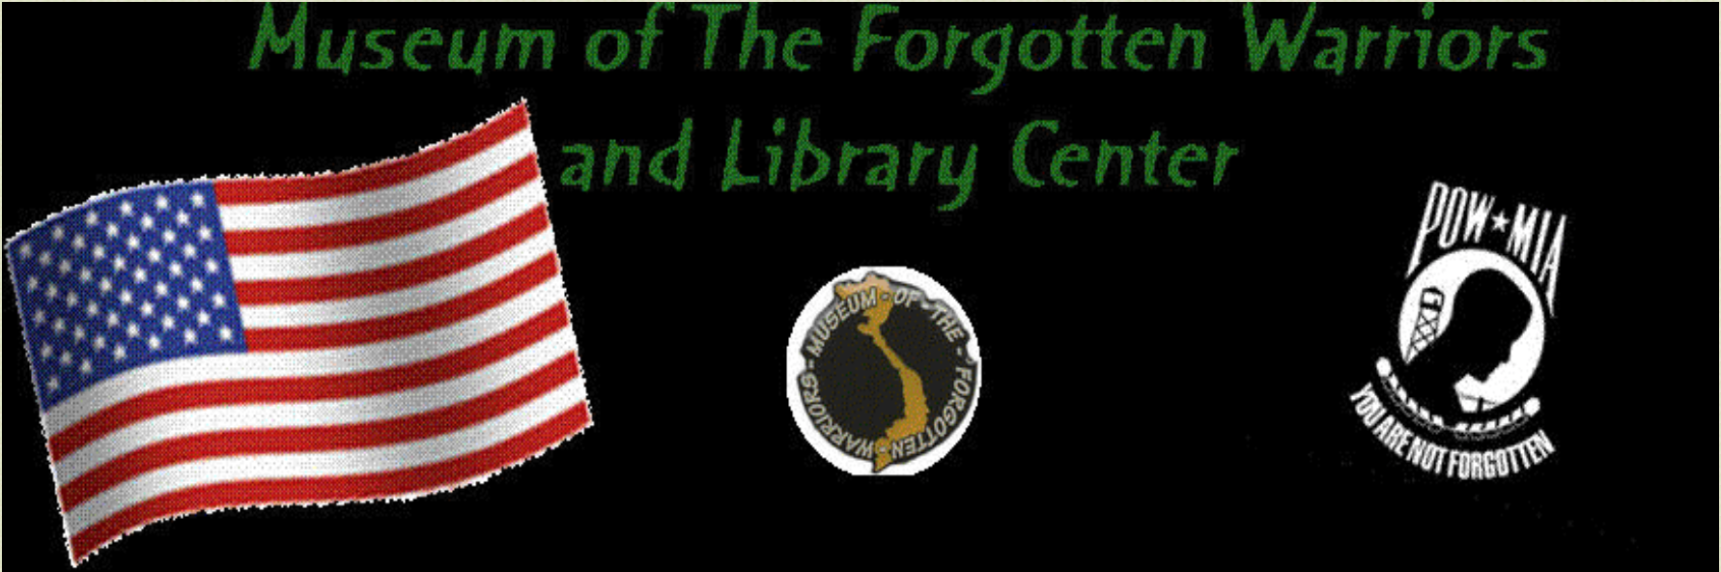

Dear Volunteers,

As January comes to an end and the new year starts, I can’t help but wonder what Dann would have said about the past year. When I picked up the reins (somewhat reluctantly), my goal was to make Dann proud and to finish his projects. I think he would have approved of what took place at the museum in 2018. With all of your help, I believe we are in a good place. I feel him looking over my shoulder and nodding approval.

Several interesting people visited the museum in January, notably Mr. Harold Bray, one of the few remaining survivors of the USS Indianapolis disaster. I can’t imagine that you don’t know the story, but if not, google it. The story is absolutely amazing. We hope to have him return for another visit. A group of Sea Cadets came to hear him tell his story, and those kids were so interested, as we all were. Don and I visited with a 98 years young Marine and listened to his story of the Battle of Midway. The McVey family visited to help with a display honoring their father, Lt. Col. McVey.

This week, an NCO group will arrive for a tour.

Bert continues to paint the second blade and is working on a riverboat scene.

Everyone likes the bazooka donated by Cory Crowell.

On a fun note, a bunch of us went to cheer Tony on in a karaoke contest. He got robbed, but we all had a good time.

If you show up on Saturdays around noon, there is usually something to eat and always some laughs.

Thank you to all the usual suspects for your help this month, especially Austin Webb. He frames all of our displays and climbs into places the rest of us don’t fit and loves to give tours. Mary is our treasurer and helps behind the scenes all the time. She keeps everything up to date and ship shape. A big thank you to Mary and Austin Webb. I depend on you a lot!

Our next board meeting will be 0900 on March 9th. Please plan to attend. We will discuss spring projects and plans.

For Dann

Roberta

