MUSEUM OF THE FORGOTTEN WARRIORS
NEWSLETTER #3 May 2018
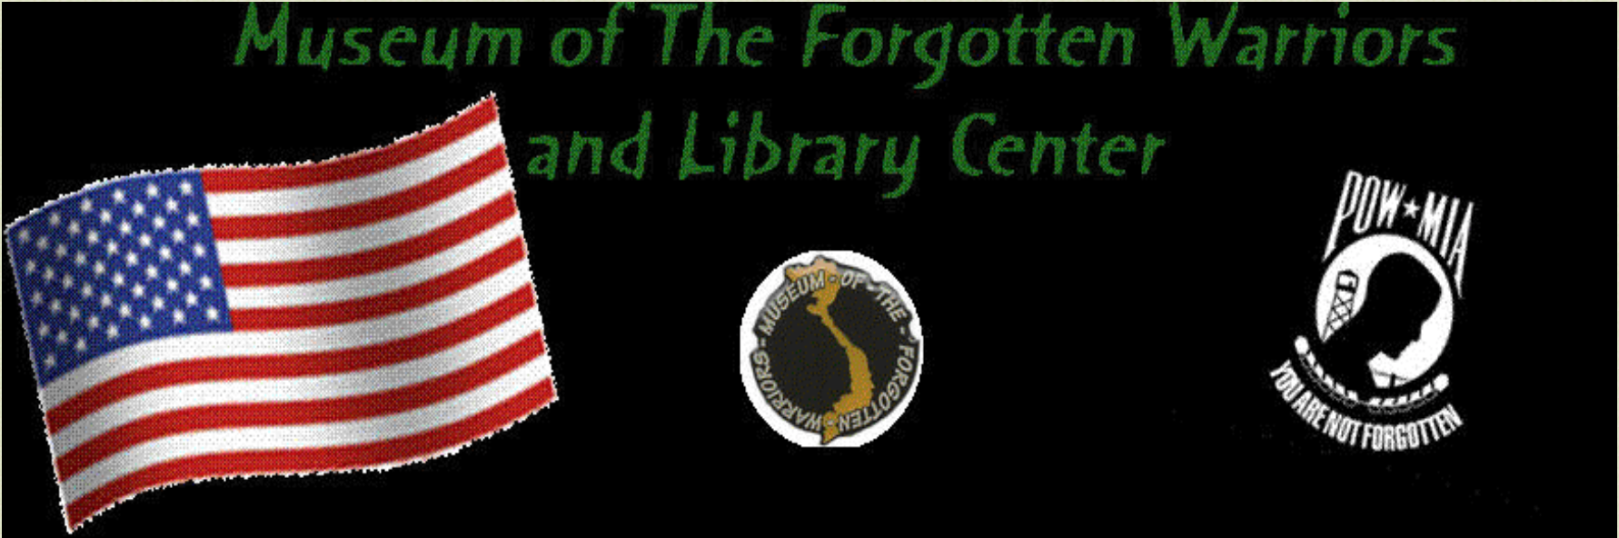

We are looking forward to Memorial Day weekend, Monday May 28. We will barbeque about noon for whomever is here. The patio counter tops were poured on May 19. Thanks to all who helped. This is one more step toward completion of the patio.

The model club has been a huge help this month. The members have cleaned, repaired, and re-hung models all over the museum. Thank you all so much! You have made great headway in a big job. There is still more to do, but it looks great.

Bert has begun painting the helicopter blades. THE BLADES WILL BE SPECTACULAR! Tony went for a trike ride with Ray . . . no disasters!

Don’s grandson Demetri, and his friend Evan pressure washed all of the equipment and the sidewalk plaques on May 12. Thank you, boys. The field across the way had been plowed the day of the big windstorm and dust was everywhere.

Don is working on several new donated displays. New stuff continues to arrive. Bill continues to catalog the collection and to try to decipher Dann’s coding system and miniature writing.

Several groups have visited throughout the month. The Duke Griego Memorial Golf Tournament at Plumas Lake Golf and Country Club fundraiser will be held on June 9. Yuba City Toyota has asked for the jeeps to be displayed over Memorial Day weekend with a portion of the sales for the weekend going to the museum. Ron Russell is working on his own fundraiser campaign.

We hope to complete the patio, some up grades to fencing, install security cameras, and add H/VAC to the old building (finally) in the next few months. Dann had a plan, and I am working to make it happen. Thank you to all volunteers for your time and effort, continued support of the museum, and me too, especially for Saturdays. You are appreciated and everyone is welcome.

Roberta, for Dann

