MUSEUM OF THE FORGOTTEN WARRIORS
NEWSLETTER #5 July 2018
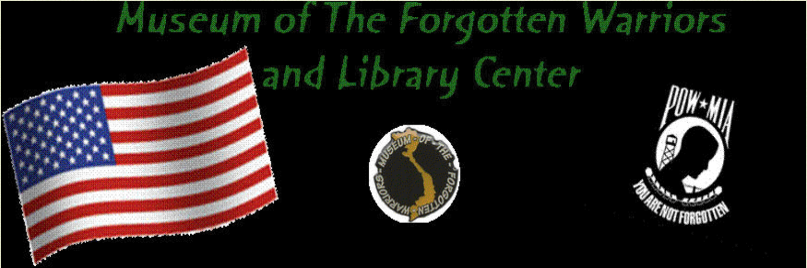

Hello Everyone,

July at the museum has been much more comfortable as the H/VAC project has been completed!
Thanks to Andy's Heating/Air and to all who helped make this happen. It was a long time goal of Dann's.

We finished some up grades to the fencing and security in the front and around the side of the museum.

We are getting close to being caught up with the on-going projects and are looking forward to being able to invite you all to a potluck in the patio soon.

I heard a rumor that some of you veterans are planning on signing up for a few hours on Saturdays. I hope it is true.

I was gone on a Saturday this month visiting southern California for a baby shower for Ceder and Erin. As you may know, they are expecting Dann’s and my first grandchild in September.
Thanks guys for covering for me.

Some new friends as well as some who hadn’t been here for a while visited the museum in July. As usual, folks were surprised and amazed. The Museum of the Forgotten Warriors is truly a star in the Yuba County crown.

Giant kudos go out to Ron Russel and the Joksch family. Ron sold clocks donated by the Jokschs and donated $1,800 to the museum.

Thanks for all your interest and support.

For Dann, Roberta

