MUSEUM OF THE FORGOTTEN WARRIORS
NEWSLETTER # 17 JULY 2019
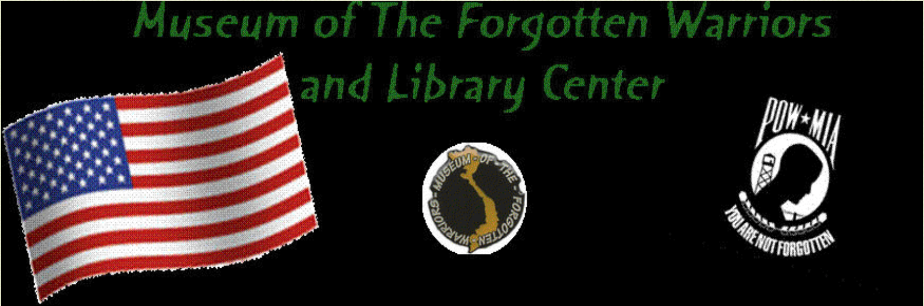

Greetings,

July has been a bit warm, and we are glad to close at 1:00 p.m. on Saturdays until the first weekend in October. However, we continue to have visitors and groups, even with the heat. Mornings are the best time to come, especially to see the static displays outside.

Jack started filling in the wall space in the patio so we can display more memorabilia. Things keep arriving, and we want to display them. The replacement of the 75 American flags destroyed during the storms around Memorial Day is on track.

On July 12, about 30 volunteers from the Air Force Reserve came out to do yard work and cleaning in the museum. Thank you so much!

The Cherry Blossom Assisted Living residents visited this month. Don and Tony did a sterling job of escorting them around the museum. Austin’s daughter sat in on a jam session with Bert and Tony. It was fun.

Bill completed the donated inventory this month, a job that began with Dann in June 2017. The 84 glass cases house a total of 1,322 donated items from 996 separate donors. This count, of course, does not include the purchased items in the glass cases and the many donated and purchased items outside of these cases throughout the museum. Thank you, Bill. We will find another project for you.

The Gothrow family donated memorabilia in honor of David Gothrow Sr. We thank you.

Bert presented me with a beautiful painting of Ainsley and me with Dann watching over us. It is very special. I will keep it in the library for a while. Please be sure to come out to see it. Bert, you are amazing. Thank you.

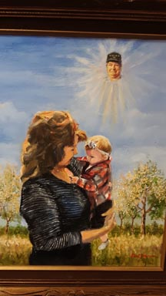

We continue to eat well on Saturdays and have a good time. Come hang out at the museum. You never know what or who might walk through the door.

For Dann,

Roberta

